**Installation:**

* Always read the prerequisites for installing it
* We need to have java 8 at least
* If we want to set java 8 for user1 and java 9 for user2. In windows, we have user variables and system variables. With that we can set

Set is the command to see all the environment variables in linux

* **Set**
* **Set | grep JAVA 🡪 to filter it**

Get into the download elastic search page and download the deb file with wget to ubuntu server

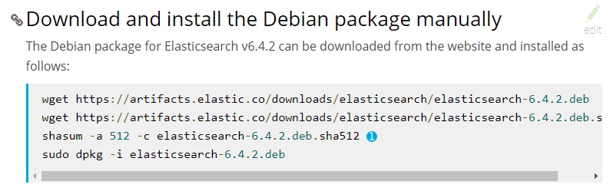

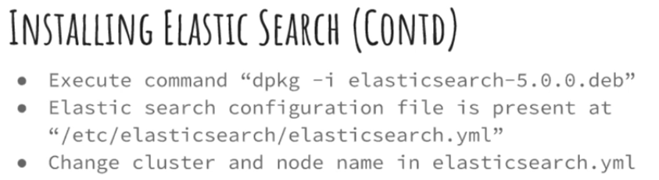

* Cluster name is the name which we give to the machine and the nodes name
* If we use public ip it is good to have elastic ip because we no need to change the configuration every time we restart the machine
* In real time we will be using private ip. So, no need to have elastic ip
* Go to the folder where we downloaded deb file and run dpkg command as above
* Go to configuration file and edit it

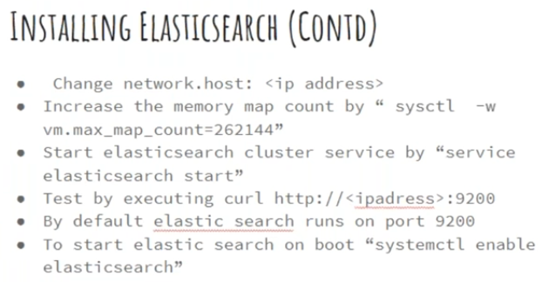

* Uncomment and change the cluster name as below

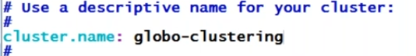

* And node name also
* Node name is the pubic DNS name of ec2 machine

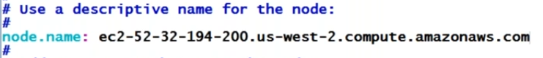

* Change the network. Host with public ip

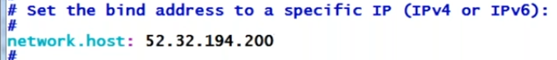

* Now save it



* We might get these errors do we need increase process and map count
* Increase the memory map as above command
* sudo sysctl -w vm.max_map_count=262144



* Open 9200 port
* Then start the service elastic search with the above command. It might get failed
* Go to default location /var/log/Elasticsearch and open global-clustering.log file. We can find any info
* Go to security groups and give all traffic to allow
* Now it can be started
* We can access with ip:9200
* It might not work, another way to check is below

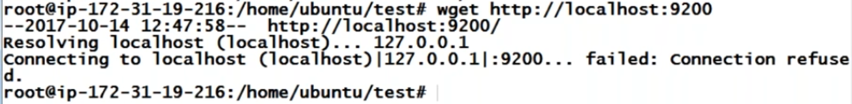

* Node name can be public or private DNS but network.host should be private ip especially in AWS
* Now we can check it with <http://publicip:9200>

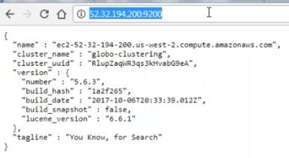

* Service elasticsearch enable 🡪 to start elastic after restarting the machine

We can the port is commented in configuration file, but it is ok as it is default. If we want to change it then we need to uncomment it

**Installation with tar file:**

